User Reference Workbook
for

Electronic lodgement of a Notification to supply a Medical Device in New Zealand

WAND
the
Web-Assisted Notification of Devices
database

Table of Contents
Introduction 1
Introduction 1
Overview 1
Assumptions 1
Help 1
What is WAND? 2
What is WAND 2
Delivery of WAND 2
Notifiable Medical Devices 2
Note/ exceptions 2
Overview of the WAND Medical Device Lodgement System 3
Introduction 3
Manufacturer's Evidence Form 3
Medical Device Notification Form 3
Security of Operations 4
Getting Started 5
Introduction 5
Medsafe 5
Accessing WAND 6
Navigation 7
Introduction 7
Navigation buttons 7
WAND Home Page 7
Functionality available on the WAND Home Page 8
Navigating between views 8
Example 8
Search 9
Search Operation 9
Mandatory Fields "" 9
Exiting Forms 10
Help 11
Introduction 11
Accessing Help 11
Help Links 11
Help Desk 11
How to Use This Document 12
Introduction 12
Sections (Device Lodgement processes) 12
Functions 12
Cross-Reference 12
Register a New Manufacturer Evidence 13
Introduction 13
Page 1 - Notification of Manufacturer's Conformity Evidence 13
New Notification 13
Enter Evidence Notification Details 14
Confirm Sponsor Name 14
Select Certification 15
Select a Manufacturer 16
No manufacturer address details 16
Add a New Manufacturer 17
Type of certification 17
Definition of a medical device 17
Option 1 18
MDD, AIMD or TGA certification 18
Option 2 18
FDA Certification 18
Option 3 19
‘Other’ Certification 19
‘System or Procedure pack’ declaration of conformity certification 19
Class(es) of Device(s) 19
Conformity Assessment 20
Notified Assessing Body 20
Issuers File Reference 20
Issuers Certification Number 20
Evidence Issue Date 20
Evidence Expiry Date 20
Page 2 – Scope of Certification as GMDN codes 20
GMDN search 21
Search for GMDN codes 22
Accepting GMDN Code List 23
Enter Restrictions on Scope 24
Page 3 – Supporting Documentation 24
Supporting Documentation 24
Add Electronic Attachments 25
Removing Attached Supporting Documentation 25
Additional Supporting Documentation 26
Remove Additional Supporting Documentation 26
Record Time Taken 26
Completing the Form 26
View Lodged Evidence 28
Vary Existing Evidence 29
Variation to a Processed Evidence 29
Variation rules 29
Steps to making a variation 29
Increasing Scope 31
Additional Supporting Documentation 31
Submit Variation of Manufacturer's Evidence 31
Medical Device Notification to Medsafe 32
Key steps in completing a WAND medical device notification 32
Introduction 33
Introduction 33
Flow Chart identifying the process of completing a Medical Device Notification 33
Create a New Medical Device Notification 34
Select the On-Line Form 34
Page 1 – Medical Device 34
Type of Notification 34
Sponsor’s Own Reference 34
Confirm Sponsor Name 34
Select Class 35
Enter Intended Purpose 35
Specific Details 36
Additional details 37
Complete Page 1 38
Page 2a – Manufacturing Details (Class 1 or No evidence) 39
Manufacturing Details 39
Select a Manufacturer 39
Add a New Manufacturer 40
Add GMDN Code 40
Additional Fields – Device System Name 41
Page 2b – Manufactures Details (Other Classes) 42
Other Classes 42
Select GMDN Code and Description 42
Additional Fields 42
Add / Remove Variant Details 44
Page 3a - Medicated / Formulated Details 44
Medicated / Formulated Details 44
Select an Ingredient 45
Add a New Ingredient 45
Enter Quantity and Units 45
Add / Remove Ingredients 46
Page 4a - Procedure Pack or System 46
Procedure Pack or System Components Australian Market 46
Enter the Component Description 47
Component Declaration 47
Page 4b - Procedure Pack or System Components Ancillary 47
Procedure Pack or System Components Ancillary 48
Enter Component Description 48
Component Declaration 48
Page 6 - Declaration 48
Declaration 49
Record Time Taken 49
Completing the Form 49
View Submitted Device Notification 51
Clone an Approved Australian Medical Device Notification 51
Clone an approved Australian medical device 51
Introduction 52
Copy a DEAL application 52
Make a copy 52
Appendix 1 – Form: Notification of a Manufacturer's Conformity Evidence 54
Page 1 – Notification Details 54
Page 2 – Scope of the Certification 58
Page 3 – Supporting Documentation 59
Appendix 2 – Form: Medical Device Notification 60
Page 1 – Notification (Specific) Details 60
When you enter the following combination in the specific details section of Page 1: 63
Form Page 3A – Medicated or Formulated Details is presented 63
When you enter the following combination in the specific details section of Page 1: 64
Form Page 4A – Procedure Pack or System Components supplied separately in the New Zealand market is presented 64
Page 6 – The notification summary and declaration 66

Introduction

Introduction | Welcome to the New Zealand Medical Device Electronic Notification (WAND) system. The electronic lodgement system provides the facility for the New Zealand Medical Device Authority to collect information about medical devices supplied in New Zealand.

Overview | This document is a reference guide to the web based WAND system. It outlines the electronic system and provides Users with instructions for lodging their Manufacturer’s Evidence and Device Notifications electronically.

Assumptions | It is assumed that Users are familiar with mouse skills and have a basic knowledge of the Web environment.

Help | Electronic user functionality Help is available for WAND. For more detail on the various forms of help refer to the Help page in this document.

What is WAND?

What is WAND | WAND (Web Assisted Notification of Devices) is a new medical device notification database for New Zealand.  WAND is a notification database that will facilitate the management of recalls and safety alerts. The presence of a medical device entry on the database will NOT indicate approval or any other endorsement of the device by the regulator.

Delivery of WAND | WAND is being delivered as a joint initiative under contract by the TGA (Therapeutic Goods Administration of Australia) but is accessed from the New Zealand Medsafe web site.

Notifiable Medical Devices | All medical devices (as defined in the Medicines Act 1981) are required to be notified, unless specifically exempted.  Medical devices that are exempted from medical device notification are:  - Products made specifically in accordance with a request by a registered health professional and intended to be used only in relation to a particular individual;  - Imported devices held in bond for export;  - In-house in vitro diagnostic devices (IVDs) for use on site only, i.e. not for use outside that laboratory.  - Medical devices supplied as part of a clinical trial  - Items imported for personal use  - The Director-General of Health may exempt specified medical devices. These would be notified in the New Zealand Gazette and publicised on the Medsafe website.

Note/ exceptions | Note: Some products that are considered medical devices overseas are regulated as medicines in New Zealand. These products are not notifiable medical devices. They include:  - Contact lens cleaning and soaking solutions  - Pregnancy test kits  - Bone cement containing an antibiotic  - Condoms containing a spermicide  - IUCDs containing copper  - Injections for a therapeutic purpose that is achieved by physical rather than pharmacological means, e.g. collagen injections  The above products are medicines and a sponsor must obtain the Minister’s consent for distribution of these products in New Zealand.

Overview of the WAND Medical Device Lodgement System

Introduction | The Medsafe WAND system provides a browser-based electronic lodgement facility for applications and supporting data to identify medical devices in the New Zealand market. Clients can perform all the necessary functions required to manage a medical device notification. WAND enables you to:  - submit a new Manufacturer’s Evidence;  - vary (increase the scope) an existing Manufacturer’s Evidence;  - submit a new notification of a Medical Devices;  - make variations to the medical device record where the Device Class is a Class III or AIMD;  - monitor the progress of submitted notifications.  The WAND electronic lodgement facility utilises a web front-end, which interfaces to a Lotus Notes database.

Manufacturer's Evidence Form | (A copy of the Manufacturer's Evidence Form is at Appendix 1.)  Manufacturer's Conformity Assessment Notification is the Manufacturer’s Evidence and this form consists of three pages:  - Page 1 – Notification Details.  - Page 2 – Scope of the Certification.  - Page 3 – Supporting Documentation.  A copy of the Manufacturer's Evidence Form is at Appendix 1.

Medical Device Notification Form | A copy of the Medical Device Notification Form is at Appendix 2.  The Medical Device Notification form is used to submit information about the Medical Device. The form consist of up to six pages however, depending upon the Medical Device being notified, only those pages that require data entry will be displayed. The six pages:  - Page 1 – Notification (Specific) Details.  - Page 2A – Manufacturing Details (for Class 1 Notifications and notifications made without supporting manufacturer evidence).  - Page 2B – Manufacturing Details (Other Classes).  - Page 3A– Medicated or Formulated Details.  - Page 4A – Procedure Pack or System Components.  - Page 4B – Procedure Pack or System Components (Ancillary).  - Page 6 – the two part Declaration. Part one is compulsory, while the second part is completed at your discression.  A copy of the Medical Device Notification Form is at Appendix 2.

Security of Operations | All access is enabled via user access names and passwords. Authorised users will have access to view and monitor all Medical Device Notifications drafted or lodged under the Sponsor username. Administrators within organisations will be responsible for active management of their own users. Access to the WAND system will allow certain user privileges such as the ability to draft but not lodge.

Getting Started

Introduction | The WAND system is accessed through your Web browser. The default for all Users will be 'Read' access.  Each User will receive an E-mail containing information to establish the correct links on their PC.

Medsafe | 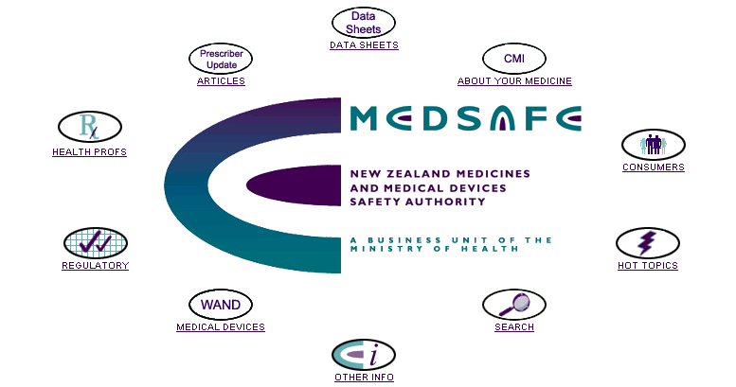

Accessing the WAND system | Access to WAND is via the Medsafe home page at: http://www.medsafe.govt.nz  The Medsafe site contains a WAND page link which provides  - user information,  - access to the TGA/SIME User Management system (for the creation and management of User Accounts by the company Administrator), and  - access to the WAND home page for the creation and management of Notifications.  Once entered, the WAND Home Page will be displayed as shown below.

WAND Home Page | 
 | Only users with appropriate username/password access will be able to access the WAND home page.

Accessing WAND | Access to the WAND system is via the Medsafe Internet Home Page (as described above)  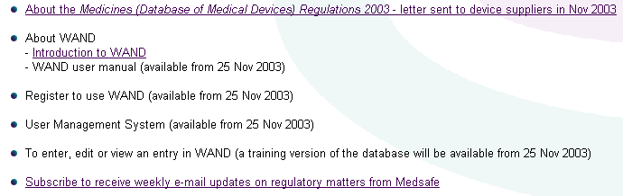
 |  | 1. | Select the relevant button
 |  | 2. | The login screen will be displayed.  Enter your login details.  Your login Name and Password will be automatically allocated to you by the SIME system following creation of your accounts by your Company system administrator. The system allows you to change your user password through the User management component.

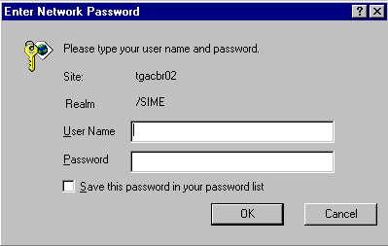
The WAND Home Page will be displayed.

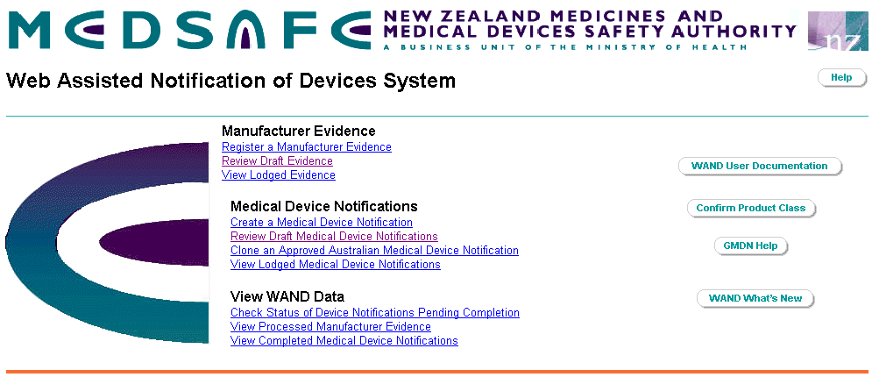

Navigation

Introduction | The WAND system is designed to be easy to use. Navigation (i.e. moving around the system) follows standard web-based hyperlinks and navigation link buttons.

Navigation buttons | Hyperlink |  |  |  | Standard hypertext navigation that will open a web form or list of forms
 | Previous |  |  | Return to the web page displayed before current page on the form
 | Next |  |  | Display the next web page of the form
 | Home |  |  | Return to the WAND Home page
 | Search |  |  | Allows users to display a specific list of forms
 | Help |  |  | Links to on-line help (see the 'Help' section of this User Guide)

WAND Home Page | From the WAND Home Page, you can use the Hyperlinks to access Manufacturer Evidence, Medical Device Notifications or view data submitted to Medsafe.

Functionality available on the WAND Home Page | The WAND Home page has four functional zones:  - Manufacturer Evidence;  - Medical Device Notifications;  - View your own Medsafe data; and  - Supporting functionality (Product Class calculator, GMDN help and a What’s New button providing access to the latest information about the operation, useability or rule interpretation of the system.).

Navigating between views | Navigating between the WAND Home page and lists of Medical Device notifications and evidence forms is achieved by selecting any of the following hyperlinks:  Review Draft Evidence  View Lodged Evidence  Review Draft Medical Device Notifications  View Lodged Medical Device Notifications  Check Status of Device Notifications pending completion  View Processed Manufacturer Evidence  View Completed Medical Device Notifications  To close a list, use the 'Home' button to return to the WAND Home page.

Example  Navigation | For example, select View Processed Manufacturer Evidence to see a view similar to the following:  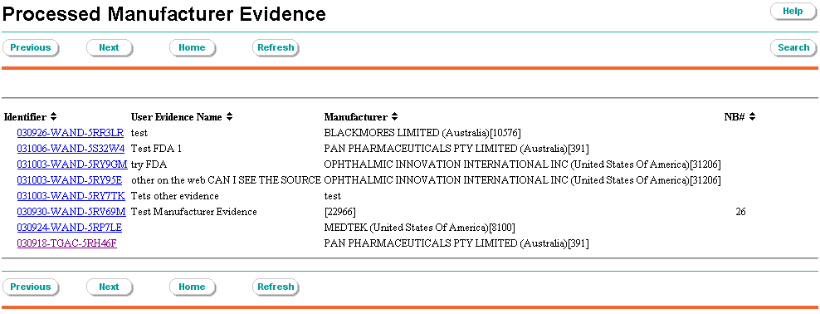  The document identifier hyperlinks open the selected document.

Search | The Search button allows users to search the list of Manufacturer’s Evidence (or Medical Device Notifications if you use that view) for relevant information within the documents contained in the view. When searching, it is important to note that a search is restricted to information contained in fields on that form or document  Select the button to display the Full Text Search window.

Search Operation | The following screen will be displayed:  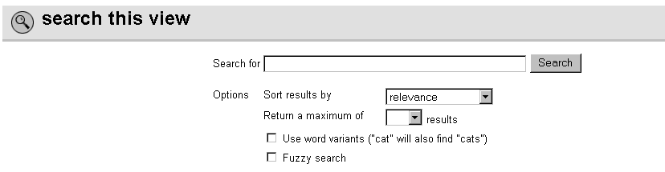

Mandatory Fields "" | Throughout the system, fields that require mandatory completion are identified using a 'red star' ().  Both the evidence and medical device notification forms must be validated by selecting the button before they can be submitted.  Where mandatory fields have not been completed, a validation message will be displayed at the top of each page of the form. The message is hyperlinked and selecting one will take you to the appropriate page to complete the mandatory requirement. For example:  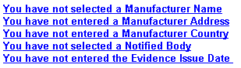  The validation message may also indicate the information supplied is inappropriate and you will have to amend the information as entered before the notification can be submitted.

Exiting Forms | To exit from a form within the WAND system:  - Select the button on the navigation bar (returns to the WAND Home page)  To exit from the WAND Home page:  - Select ‘Home’ on the browser navigation bar; or  - Select 'File-Close' on the browser navigation bar.

Help

Introduction | Each of the WAND web pages has its own on-line help component.

Accessing Help | Accessing Help within this system is achieved by selecting the button on the Action Bar at the top of each screen.

Help Links | Within the Help system, blue text indicates links to more help associated with that topic.

Help Desk | If at any time you are experiencing problems using SIME or need further assistance, contact the TGA SIME Help Desk:  • E-mail: tgasime@health.gov.au  • Phone: 02

How to Use This Document

Introduction | This User Guide should be used in conjunction with the WAND system. It provides a step-by-step description of each of the functionality available to the user in order to become familiar with the Device Lodgement processes contained within the WAND system.  The WAND system is designed to support the creation and submission of:  - a Manufacturer's Evidence; and  - a Medical Device Notification to describe the medical device supplied in New Zealand.

Sections (Device Lodgement processes) | This User Guide describes how to submit a Manufacturer's Evidence and submit a Medical Device Notification. It is structured in Sections associated with the following topic areas:  - Submit New Evidence;  - Vary Existing Evidence;  - Make a new Medical Device Notification;  - Clone an application submitted to TGA for an Included Medical Device entered on the ARTG;  - Clone a Copy of a completed Medical Device Notification;  - Vary a Completed Medical Device Notification.

Functions | Each Section describes the functions that the User will come across in the Device Lodgment Process. The function describes the steps that the User should follow to carry out that function.

Cross-Reference | Where steps within one Function can be followed using another Lodgement process, those steps will be referred to by cross-referencing back to the Function and the Section (Lodgment Process) that details those steps.  Cross-Reference is italicised in this User Guide.

Register a New Manufacturer Evidence

Introduction | To register a Manufacturer's Evidence you will need to fill out the Manufacturer's Conformity Assessment Notification form correctly (see Appendix 1 for an overview), and then submit it with any appropriate supporting documentation. This will then be returned to you and, when accepted, can be used to support subsequent medical device notifications.

Page 1 - Notification of Manufacturer's Conformity Evidence

New Notification | From the WAND Home page, select 'Register a Manufacturer Evidence'. There are three screens or pages, the first screen you will see is Page 1.  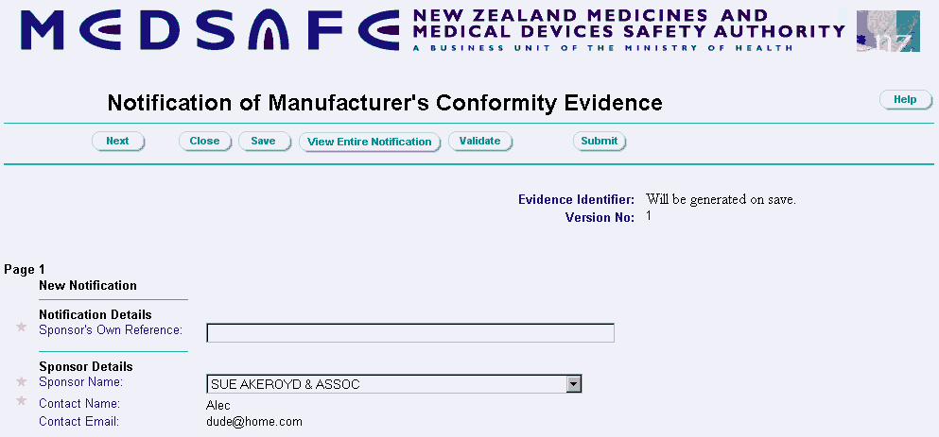  Note:  - The Version will display “New Notification”.  - Version No = 1.  - The unique Evidence Identifier will be generated automatically (when you save, close or validate the form, or if you go to the next page of the form).  - Login details including your Sponsor name, contact details and email contact will be displayed (based on your user name details).

Enter Evidence Notification Details | Enter a description of the Manufacturer’s Evidence you are about to submit. The description is used to uniquely identify the Notification within your own business organisation. The description should be uniquely meaningful to yourself and is used throughout WAND to identify the evidence in system views and lists.  Note:  1. This entry will be displayed in the following lists:  Review Draft Evidence  View Lodged Evidence  View Processed Manufacturer Evidence  - Enter up to 60 characters of text.

Example of the Review Draft Evidence screen (identifies draft notifications where work is in progress)

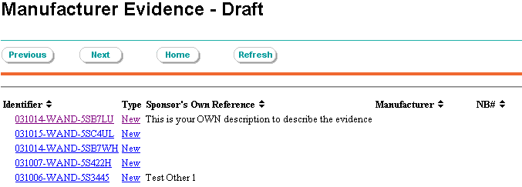

Confirm Sponsor Name | The Sponsor name is automatically populated based on the user login.

Select Certification | Certification details must be selected from the drop-down list:  The source of Certification is selected from an approved list:  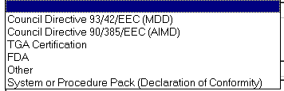  - The options cover European, TGA and FDA Certification;  - The ‘Other’ option is to collect information for alternate certification; and  - The ‘system and procedure pack’ option is to collect declarations made by a local assembler.  Note: Depending on the selection, additional and/or different fields will be added to the form. These fields will be address later in this document.

Type of certification | For the purpose of this manual, the certification types are presented as options, where the option number groups the way the form will behave and identifies the common type of information that is requested.

 | Subject to the response to the certification question the form presents differently
Option 1 | Council Directive 93/42/EEC (MDD)
 | Council Directive 90/385/EEC (AIMD)
 | TGA Certification
 | System or Procedure pack (Declaration of conformity)
Option 2 | FDA
Option 3 | Other

Select a Manufacturer | Use the button to access the Manufacturer search window:  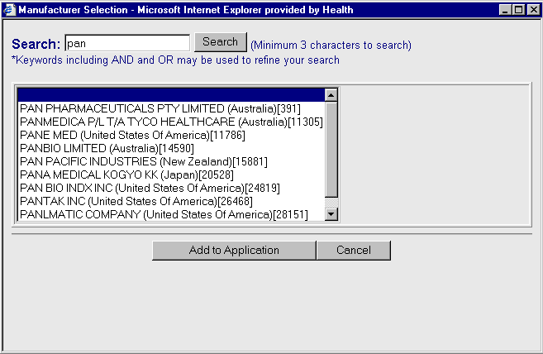  - Enter a minimum of three characters of the Manufacturer’s name.  - Select 'Search' or hit ‘Return’. A list of ‘like’ manufacturer names will be displayed which contain the entered string. The result will also include country and the TGA Client Id Number.  - Select 'Add to Application'. This will close the Manufacturer search window and populate the Manufacturer Name field on the form.  - Select the appropriate Manufacturers address from the drop-down list.  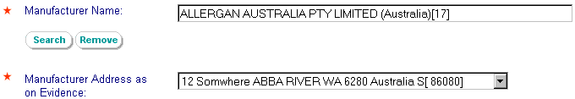  Note:  - Country and Client Id details are displayed on the form.

No manufacturer address details | Where a manufacturer name is selected from the name search list and the address details are NOT included in the address dropdown list, use the button to deselect the chosen manufacturer. This will return the three text boxes to enable entry of a New manufacturer name with associated address information. (As shown below).

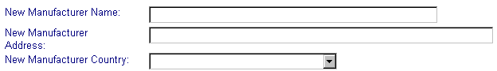

Add a New Manufacturer | If the Manufacturer is not available in the manufacturer code table list (i.e. you have not obtained a result on your search for a manufacturer), you will be able to enter new manufacturer details as part of the submission of Manufacturer Evidence. These details will be entered by TGA into the manufacturer code list for later selection.  Enter details in the following fields (and select the country from the drop-down list)

Type of certification | For the purpose of this manual, the certification types are presented as options, where the option number groups the way the form will behave and identifies the common type of information that is requested.
 |  |  | Subject to the response to the certification question the form presents differently
 |  | Option 1 | Council Directive 93/42/EEC (MDD)
 |  |  | Council Directive 90/385/EEC (AIMD)
 |  |  | TGA Certification
 |  |  | System or Procedure pack (Declaration of conformity)
 |  | Option 2 | FDA
 |  | Option 3 | Other

Definition of a medical device | Notification of a medical device in the New Zealand market is defined in terms of its Class. Consequently, each certification option seeks information in terms of a product’s Class and subsequent GMDN nomenclature code.

Option 1  MDD, AIMD or TGA certification | For MDD, AIMD or TGA the form builds to collect administrative information about the evidence:  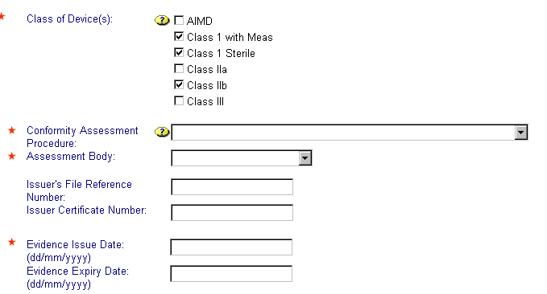

Option 2  FDA Certification | 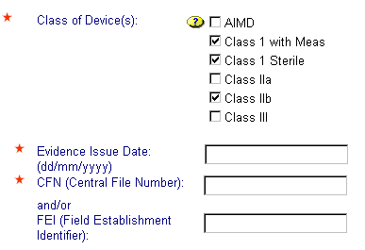  The Central File Number (or FEI field establishment identifier) is issued by the FDA to identify the certification of the manufacturer and can be found on your copy of the evidence

Option 3  ‘Other’ Certification | 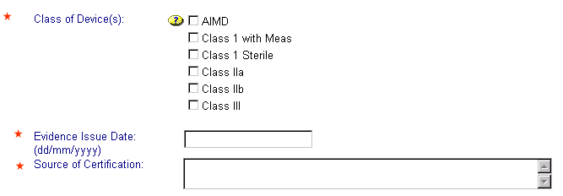  The Source of Certification is free text and should clearly identify the type of certification issued to the manufacturer and by whom.

‘System or Procedure pack’ declaration of conformity certification | 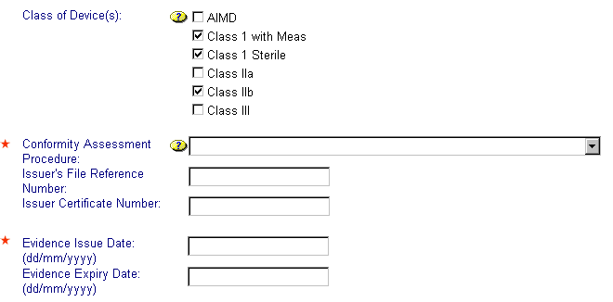

Class(es) of Device(s) | One or more Class(es) of Devices can be covered by the Manufacturer’s Evidence. To select more than one Class, tick the appropriate choices:  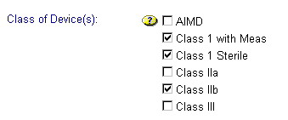

Conformity Assessment | Where a Conformity Assessment type is required, you will be required to select one of the following:  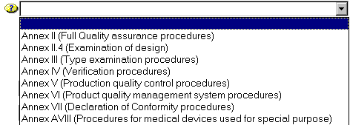

Notified Assessing Body | Select the appropriate Notified Assessing Body from the drop-down list provided.

Issuers File Reference | The Issuer's File Reference Number is to record any administrative reference noted on the conformity certificate.  The field is not compulsory and is limited to a maximum of 30 characters.

Issuers Certification Number | The Issuer Certificate Number is to record the administrative Certificate number noted on the conformity certificate.  The field is not compulsory and is limited to a maximum of 15 characters.

Evidence Issue Date | The Evidence Issue Date is the date the evidence was issued and must not be earlier than five (5) years from the current date.  The field is compulsory and is entered in the format ‘dd/mm/yyyy’.

Evidence Expiry Date | The Evidence Expiry Date is the date the evidence will expire. It is entered in the format ‘dd/mm/yyyy’.  If left blank, the expiry date will default to 5 years from the Evidence Issue date.  When all entries on Page 1 are complete, select button to display Page 2 – Scope of the Certification.

Page 2 – Scope of Certification as GMDN codes

Scope of certification - validation | So as to maximise confidence in the information provided in the eventual medical device notification, the notification will be made against the submitted manufacturer evidence. This evidence is sized (or scoped) to define the products the manufacturing process covers by GMDN code. This scope will limit the GMDN code choices available in the final notification.

Scope of the Evidence | The evidence is scoped to cover the products of interest for a subsequent medical device notification. The GMDN codes can be identified and added to your evidence by using the GMDN search function.

GMDN search |   The ‘Search’ button opens the search function form where you can select appropriate GMDN codes to scope your evidence.

Search for GMDN codes  Select | In the ‘Search’ field enter a minimum of three characters to search for the desired GMDN descriptive string. In this instance, the search is based on “guide”. Hit "Return" on the keyboard or Select the 'Go' button with your mouse.  The search result will then display an alphabetical list from which one or more GMDN codes may be selected (hold the ‘Ctrl’ key down to make multiple selections).  The ‘Select’ button will move any highlighted GMDN codes from the top or Select box, to the second – GMDN associated with evidence box.  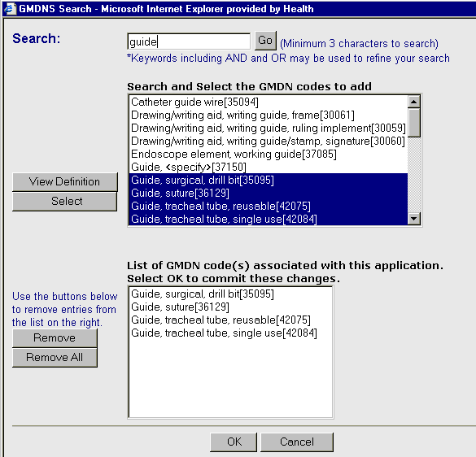  To assist in selecting the most appropriate GMDN codes, you can view the definition of a GMDN code by highlighting it and then hit the ‘View Definition’ button.

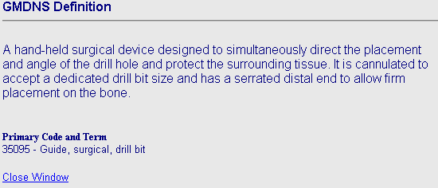

Other functions available on this sub-form:

View Definitions Button | The 'View Definition' button provides a detailed explanation about the selected (highlighted) GMDN Code.  Select the description from either view window then select 'View Definition'.  Note:  - If you have selected more than one GMDN code (see 'GMDN Select Button') the definition will display the first value in the selection.  - For synonyms, the target GMDN for the synonym will be displayed in the View Definition window but the Primary code and term are shown in the view definition.
GMDN Remove Button | Select one or more values in the ‘GMDN associated with evidence’ field box, select the 'Remove' button to remove the selected GMDN code from this list.  'Remove all' will clear the smaller view window enabling a new search/select to populate this box.
Synonyms | Synonym items are returned and are displayed with the word Synonym displayed before the code.  For example:  Synonym-Needle guide[15868]

Accepting GMDN Code List | Select 'OK' to accept the list. This will pass the list to the notification form and you will return back to Page 2 of the Manufacturer Evidence form.  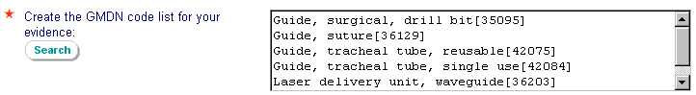

Enter Restrictions on Scope | The evidence you are using may include restrictions on the scope of the certification. If required, this field enables you to enter details of any restrictions placed on the evidence being submitted:  Note:  1. Maximum entry of 2000 characters per name.

When all entries on Page 2 are complete, select the button to display Page 3 – Supporting Documentation.

Page 3 – Supporting Documentation
Supporting Documentation | Documents required as evidence must be electronically attached to the application. Additional larger documentation may also be supplied as supporting documentation, the format in which it will be supplied should be included on this form.  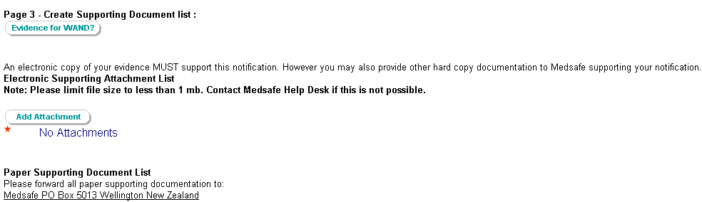

Add Electronic Attachments | Manufacturer Evidence must be supported by electronically attaching documentation, which will be used to assess the suitability of the evidence. Attached documentation may be scanned copies or any other electronic record.  Select the button to open the Supporting Documents window:  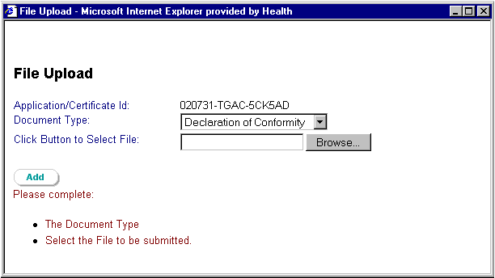  Select the 'Document Type' from the drop-down list and  use the 'Browse' button to locate the document on your PC/network.  When the document has been selected, use the button on this 'pop-up' window to copy the file to the notification of evidence form. You will return to Page 3 of the Manufacturer’s Evidence form.  Multiple files can be attached if required.

Removing Attached Supporting Documentation | To remove supporting documentation from the evidence form, select the hyperlink 'Remove' :  The following confirmation message box will be displayed:  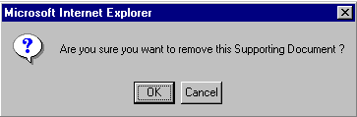

Additional Supporting Documentation | Large paper based documentation or reports from assessing may also be submitted via Fax, Post or Courier. You can register your intent and the type of information that will be sent to Medsafe.  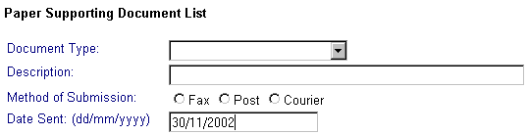  Note:  - All fields must be entered.  - Date defaults to 'today' but can be edited to suit.  Select the button to insert the information to the table below.  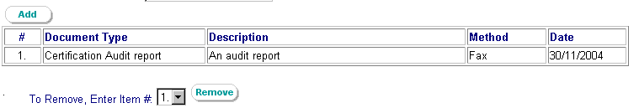  Note:  - You can 'add' multiple documents by repeating the above process (see 'Additional Supporting Documentation').

Remove Additional Supporting Documentation | To remove, select a number in the 'Enter Item #' drop-down list corresponding to the documentation item you wish to remove from the list.  Then select the button to remove that selection.

Record Time Taken | To get a sense of the time taken to complete the notification, the form includes an option to record the time it takes to complete the form:

Completing the Form | The form may be saved at any stage of your data entry. Similarly, 'Close' will save the form and return you to the WAND Home page.
 |  |  | This will display details of all the fields completed for the Manufacturer's Evidence form. Functions that you can perform are:
This will perform a validation of the form against certain business rules such as ensuring all mandatory fields have been entered. The validation messages will appear at the top of each page such as (for example):

These messages are 'hyperlinked' and selecting one will take you to the page containing the error to complete the entry.

When all error have been fixed you will see the following validation message:
This will perform a validation and then submit the form.

If the validation is successful the form will be submitted with the following message:

(user_id), your Manufacturer's Evidence has been submitted for processing.

Thank you

Note:
- Neither TGA or Medsafe have access to your (the Client) draft copies of your Notifications.
- Submitting a form sends the form to a database within TGA for subsequent replication to Medsafe.

View Lodged Evidence | After a Manufacturer's Evidence has been submitted, you will be able to see the Notification in the lodged evidence list. Evidence will remain in this lodged list until it is processed.  To view lodged evidence select:  View Lodged Evidence on the WAND Home page  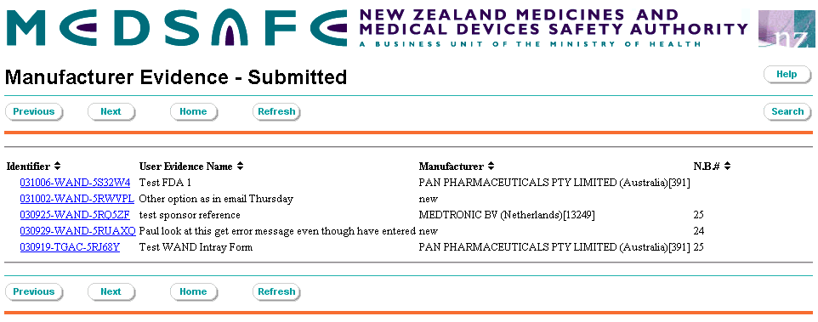

Vary Existing Evidence

Variation to a Processed Evidence | Information contained in an already processed evidence may need to be varied, expanded or the information updated at some time.  Only some details in a Manufacturer's Evidence can be varied.

Variation rules | Information that can be changed as part of a variation includes:  - Selection of additional Class ( as long as the conformity evidence covers the addition)  - Change the "Issuer's file reference number"  - Change the "Evidence Certificate number"  - Update the "Reissue date", in which case the expiry date will be advanced 5 years, based on this new date.  - Add additional GMDN codes  Please note the system validation will check that "Electronic Supporting" information has been added to the variation. In some instances it may only be necessary to re-add another copy of the original documentation. If the administrative fields are changed however, the new certification or conformity document must be added.

Steps to making a variation | Only some details in a Manufacturer's Evidence can be varied by carrying out the following steps:
 |  | 1. | Select "View Processed Manufacturer Evidence" on the WAND Home page.
 |  | 2. | Find and select the hyperlink to the chosen 'accepted' Manufacturer's Evidence.
 |  | 3. | Select the button.
 |  | 4. | The following message will be displayed:  "A variation document has been created - refer to the Review Draft Evidence View from the WAND home page".  A copy of the selected evidence has been placed in your ‘Review Draft Evidence’ box for processing.  The Variation document is identified by your own identification string and by the "variation" label in the type column of the view.
 |  | 5. | Select button to close the 'accepted' Manufacturer's Evidence view. This will return you to the WAND Home page.
 |  | 6. | Select "Review Draft Evidence" on the WAND Home page.
 |  | 7. | Find and select the hyperlink to the Manufacturer's Evidence that you wish to vary.  The Variation document is identified by your own identification string and by the "variation" label in the type column of the view.
 |  | 8. | Confirm that once selected, the variation form correctly displays the next version number (i.e. No. 2):  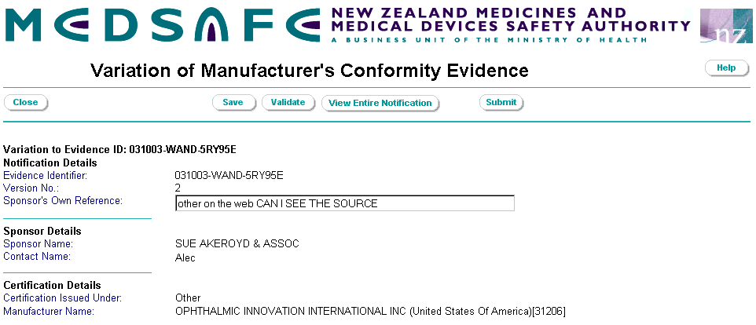
 |  | 9. | Select button to edit the form. The form is displayed but note that a restricted set of fields can be edited:  - The Sponsor's own reference. It is strongly recommended you amend the description to indicate the evidence notification is a variation.  - Add additional device classes  - Amend or enter data in the File reference field  - Amend or enter data in the Certificate Number field  - Enter the evidence "Re-Issue" date  The Variation Expiry date will be recalculated and advanced 5 years from the re-issue date.

Increasing Scope | The scope of the evidence can be increased by the addition of new GMDN codes. Existing GMDN Codes cannot be edited.  Codes can ONLY be added, not removed.  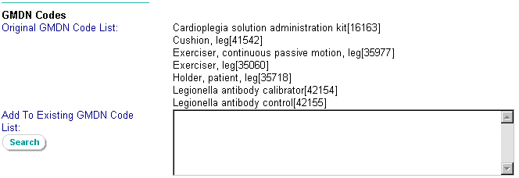

Additional Supporting Documentation | Additional electronic supporting attachments must be added to cover the variations sought. In some instances, the original supporting documents will be added again.  Original attachments and details of the submission of paper documentation cannot be removed.  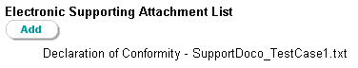  Note:  - there is no hyperlink 'Remove' to remove the original supporting documentation.  - Additional supporting attachments and documentation can be added and removed (as detailed in the 'Add/Remove Additional Supporting Documentation' functions in the Submit New Evidence section of this guide).

Submit Variation of Manufacturer's Evidence | 'Validate' and 'Submit' function in the same way as submitting new evidence.  The variation to Manufacturer's Evidence can be viewed using the 'View Lodged Evidence' selection on the Medsafe Home page. The variation will be viewable in this list until processed whereupon it can be viewed from the 'View Processed Manufacturer Evidence' .

Medical Device Notification to Medsafe

Key steps in completing a WAND medical device notification
STEP 1: Identify Notifiable Medical Devices

Is the product you are supplying a medical device within the meaning of the Medicines Act 1981, and not exempt?

STEP 2: Obtain Access to WAND

- Submit Sponsor Details Form
- Submit E-business Access Form
- Set up user accounts

STEP 3: Obtain Information from Manufacturer

- Risk Class of device
- Site of manufacture
- Intended purpose of device
- GMDN grouping (if known)
- Manufacturer Evidence of Conformity Assessment (optional)

STEP 4: Determine Device Class

Using
- Information from manufacturer OR
- “Confirm Product Class” program in WAND
determine the risk class by the highest risk device

STEP 5: Determine the GMDN Code

Using
- Information from manufacturer OR
- GMDN identification tools in WAND
determine GMDN code

STEP 6: Manufacturer Evidence of Conformity Assessment

(OPTIONAL)
- Register Manufacturer Evidence in WAND
- Attach Conformity Assessment Certificate in WAND having obtained or created an electronic copy of the Conformity Assessment Certificate.
- Validate information and submit to Medsafe

STEP 7: Create a Medical Device Notification

Create Medical Device Notification in WAND against acceptable conformity evidence or by the No evidence option. Any notification without evidence will be appropriately flagged
No further action required

No

Yes

STEP 8: Declaration and Validation

- Complete declaration and validate notification
- Submit notification to Medsafe electronically.

Introduction

Introduction | The Medical Device notification database provides an on-line environment for recording medical devices supplied in New Zealand.  Appendix 2 provides copies of the various pages that can be used in making a Medical Device Notification. The flow diagram shown below, identifies the various pages that will be made available subject to the responses in the Yes/No medical device detail section of the form.  The client can create a new Medical Device Notification by one of four processes:  - Create a Medical Device Notification;  - Clone an application submitted to TGA for an Included Medical Device entered on the ARTG;  - Clone a Copy of a Completed Medical Device Notification; or  - Vary a Completed Medical Device Notification (for Class 3 or AIMD).

Flow Chart identifying the process of completing a Medical Device Notification
Please note, a notification can be made for a high risk device without appropriate evidence, however the notification will not be acceptable in the event of combining information as part of a joint agency.

Create a New Medical Device Notification

Select the  On-Line Form | From the WAND Home page, select 'Create a Medical Device Notification'. The first screen you will see is Page 1.  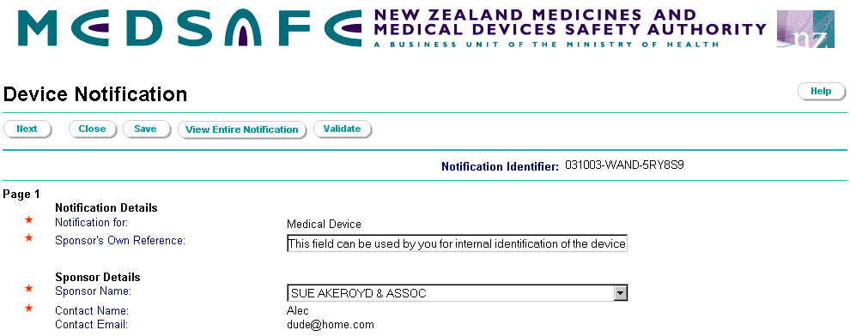  Note:  - The Notification Identifier will be generated automatically (when you save, close or validate the form or if you go to the next page).  - Details including your Sponsor name, contact details and email contact will be displayed based on your user name login details.

Page 1 – Medical Device
Type of Notification | The notification for field will be automatically populated as a Medical device.  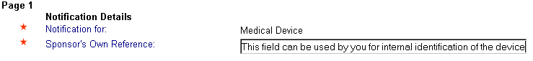  The Notification is to identify the availability of a medical device in the New Zealand market.

Sponsor’s Own Reference | Enter a description of the Device Notification for your own management of the notification. The description can be used to uniquely identify the Notification within your business organisation and as such should be uniquely meaningful to yourself.  Note: Maximum entry is 60 characters.

Confirm Sponsor Name | Confirm the Sponsor Name populated from your user login Id

Select Class | Select a Class from the drop-down list:  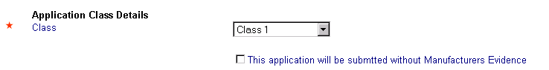  Note: The Class choice is based on a dropdown list. All medical devices will be recorded with a Class however a notification can be made for a high risk medical device without appropriate supporting manufacturer evidence.  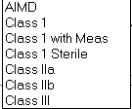  - Manufacturer Details are collected in the medical device notification where the entry is a Class I or the option to make a notification for a higher Class device without manufacturer evidence is chosen.  - Manufacturer information will be read from the supporting Evidence for all other classes.

Enter Intended Purpose | Enter text to describe the intended purpose of the Medical Device:  Note: 1. Maximum entry is 500 characters.  2. The entry is intended to collect the manufacturer’s intended purpose. It is NOT intended to collect a functional description of the medical device.

Specific Details | Respond with a 'Yes' or 'No' ('No' is default) to provide general details about the medical device. Questions will open subject to your response and subsequent pages will also be added to the notification.  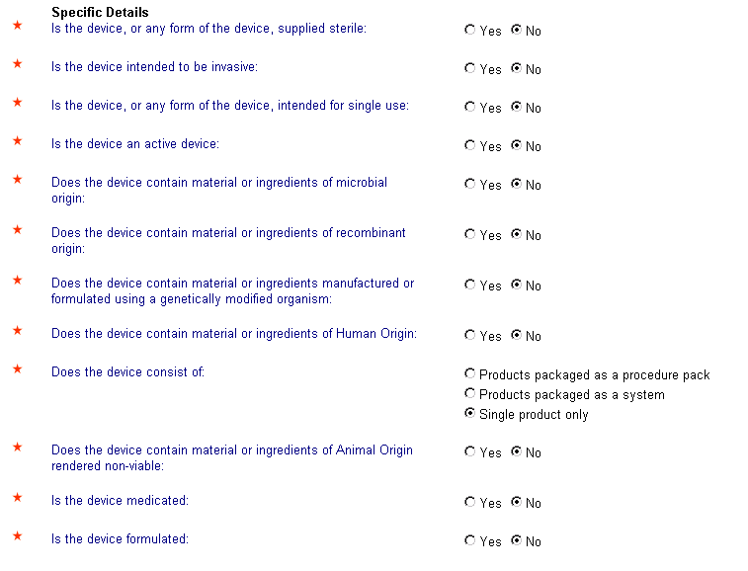

Additional details | Depending on the selection of questions answered above, some ‘Yes’ responses will display additional questions. These questions have been outlined below:

Human Origin | A 'Yes' response to a Device containing human origin will display a second question about Human Blood:  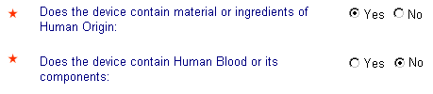
Animal Origin Single product | A 'Yes' response to an Ingredient being of Animal Origin and the device is a single product will display two additional fields:  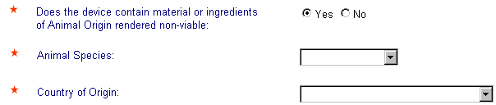
Animal Origin system or procedure pack | Note: Where the device consists of a procedure pack or a system, an additional question is added concerning the presence of animal origin in any of the individual components in the pack. A ‘Yes’ response will result in details being collected at Page 4a against the respective components.  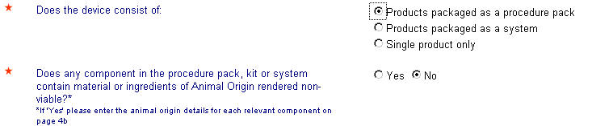
Product Packaged as a system | If 'Products package as a system' is selected:  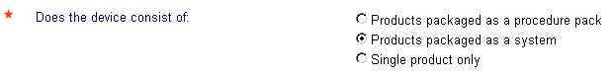  the following field will be displayed on Page 2b:
Medicated or Formulated Device | If a 'Yes' response to one or both of the following is selected:  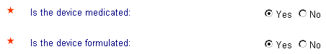  then Medicated or Formulated details will be required to be completed (Page 3a of the form).

Complete  Page 1 | When details on Page 1 have been completed select button. Manufacturer Details can now be entered. The page shown will depend on the Class of the device, page 2a for a Class 1 and where you have selected the evidence exemption, and page 2b for all other classes.

Page 2a – Manufacturing Details (Class 1 or No evidence)
Manufacturing Details | If a 'Class 1' was selected on Page 1, Page 2a will be the next page displayed. Search for details about the manufacturer or use the New Manufacturer option as discussed in the Manufacturer Evidence  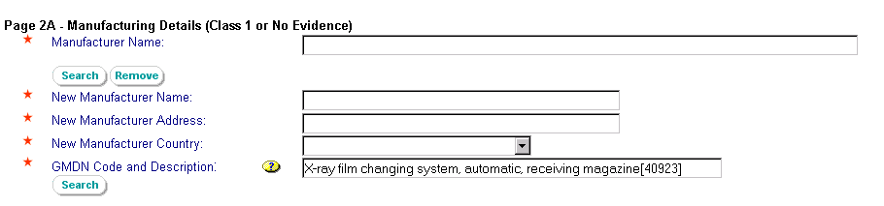

Select a Manufacturer | Use the button to access the Manufacturer search window:  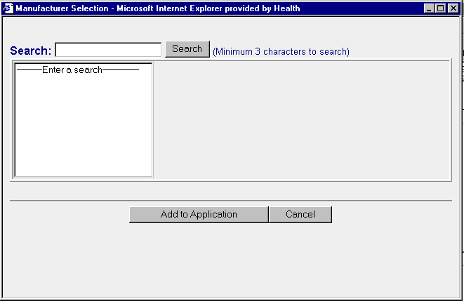  - Enter a minimum of three characters of the Manufacturer’s name  - Hit "Return" or Select 'Search' with your mouse. A list of manufacturer names will be displayed with ‘like’ names entered. The result will also include country and Client Id Number.  - Select 'Add to Application'. This will close the Manufacturer search window and populate the Manufacturer Name field:

- Select the address from the address dropdown. The number in the string is an internal computer generated value for assigning uniqueness.

Note:
- Country and Client Id details are displayed on the form.
- The Manufacturer Address can be populated from a drop-down list of recorded addresses.
- If the address is not included in the dropdown list, please use the "Remove" button to remove the manufacturer name and use the "New Manufacturer" option to record the name and address information.

Add a New Manufacturer | If the Manufacturer is not known to TGA (ie. you have not obtained a result on your search for a manufacturer), you can enter new manufacturer details as part of the submission of a Medical Device Notification for a Class 1. These details will be entered by TGA into the list of manufacturers for future use.  Enter details in the following fields (and select the country from the drop-down list).  Note:  - This feature can also be used where the manufacturer address is not known to the manufacturer lookup table.  - Maximum entry for the address field is 150 characters.

Add GMDN Code | Add the GMDN Code to the following field:
 |  | 1. | Select the button.
 |  | 2. | Enter text in the search field.
 |  | 3. | Select 'OK' to return back to Page 2a with the GMDN code field now populated with the selected result.

Additional Fields – Device System Name | If 'Products packaged as a system' is selected on Page 1 then the following free text field will be displayed:  Note:  - Maximum entry is 60 characters. Please only record the name of the device, not a description  - Only one name is entered.

Page 2b – Manufactures Details (Other Classes)
Other Classes | If a class other than 'Class 1' is selected on Page 1, the manufacturer information and other fields are read from the appropriate evidence you have submitted to cover this notification.  This is done by firstly selecting the manufacturer from the drop-down list:  and then from your list of Evidence submitted for that manufacturer,  select the appropriate evidence number (using the description you entered to define the evidence to assist in the selection) to cover the device which is the subject of this medical device notification. The evidence can be selected from the drop-down list of your own previously submitted evidence.  Note: Not only is the evidence number shown in the pick-list but also your evidence description.)  The Manufacturer's Address will be populated along with other fields of Medsafe administrative information, such as:  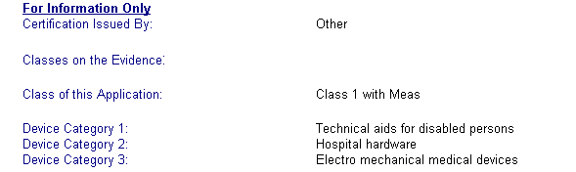  which can be used to confirm that the correct Evidence for the nominated Class of this notification has been selected.

Select GMDN Code and Description | Select the GMDN code that refers to your product from the drop-down box, where the code list is provided from the chosen evidence:  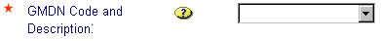  Selecting a GMDN will automatically populate additional display fields (for example) that will be used within Medsafe for reporting and sorting purposes.  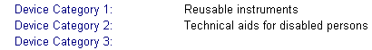

Additional Fields | You may find additional fields that require completion depending upon the responses to the device details of page 1.

Device System Name | If 'Products packaged as a system' is selected on Page 1 then the following field will be displayed:
Product Name | When ever a Class III or AIMD Device Class has been selected or when ever Evidence with a Conformity Assessment Procedure is:  - Schedule 3 Part 3 (Annex 4); or  - Schedule 3 part 5 (Annex 6),  then the Product Name of the medical device is entered.  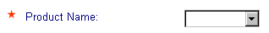
Variant Details | Three (3) additional fields will be displayed for a Class 3 or AIMD notification:  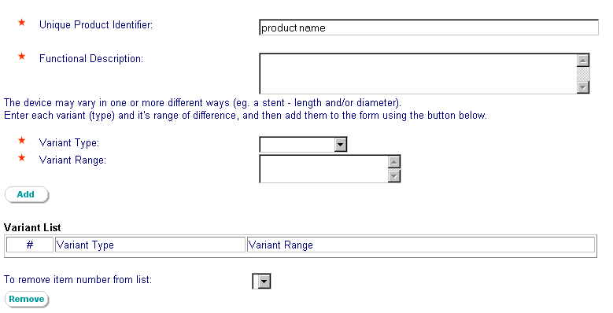  All three fields will be displayed if the Notification is:  - Class III; or  - AIMD;  Note:  - Functional Description, free text field to describe the device (maximum field size: 500 characters).  - Variant type – select from picklist (and note it includes units)  - Variant Range (maximum field size: 100 characters).

Add / Remove Variant Details | Select details in the 'Variant Type' from the drop-down list and enter 'Variant Range' fields (see above).  Select the button. Details will be displayed in the Variant List:  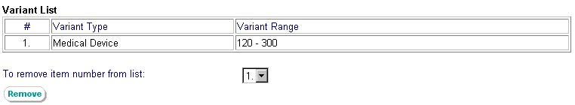  To remove, select a number corresponding to the Variant you wish to remove from the drop-down list.  Then select the button to remove that selection.

Page 3a - Medicated / Formulated Details
Medicated / Formulated Details | Page 3a will be provided where a 'Yes' response to one or both of the following was entered on Page 1:  The following fields will be displayed on Page 3A, if the device is Medicated or Formulated:  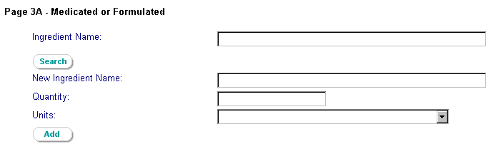

Select an Ingredient | To select an ingredient from the Ingredients database, select button.  The following window will be displayed:  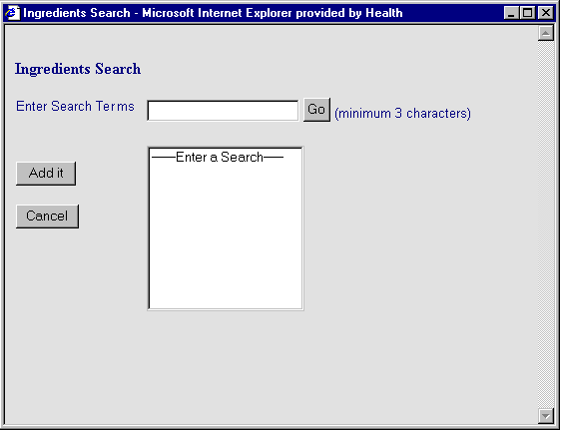
 |  | 1. | Enter the text in the 'Enter Search Terms' field.  (Note a minimum of three characters may be used)
 |  | 2. | Select 'Go'. A list of 'like' terms will be displayed.
 |  | 3. | Select the ingredient from the list and use the 'Add it' button to add the Ingredient to Page 3a of the form.

If the ingredient is not available from the search list, close the Ingredient Search window using the ‘Cancel’ button and enter the ingredient details into the 'New Ingredient Name' field. (Refer ‘Add a New Ingredient’ below)

Add a New Ingredient | If the ingredient is not available from the ‘Search Ingredient’ list, the ingredient name can be entered directly into the ‘New Ingredient Name’ field as shown below:

Enter Quantity and Units | In all cases for Medicated / Formulated details, enter details of the ingredient 'Quantity' and Select 'Units' from the drop-down list provided:

Add / Remove Ingredients | After the Ingredient, Quantity and Unit have all been entered, select the button to display the details in the Ingredient List:  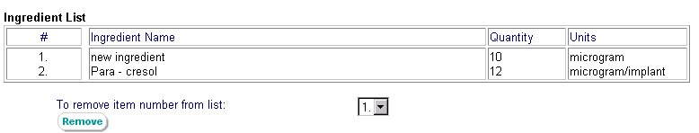  To remove, select the number corresponding to the ingredient you wish to remove from the list using the drop-down list.  Then select the button to remove that selection.

Page 4a - Procedure Pack or System
Procedure Pack or System Components Australian Market | Where a 'Yes' response was provided to the device being procedure pack or system on Page 1 and a ‘Yes’ response is also provided to the additional question re “Does the product contain a medicine that is supplied separately in New Zealand (as shown below from Page 1):  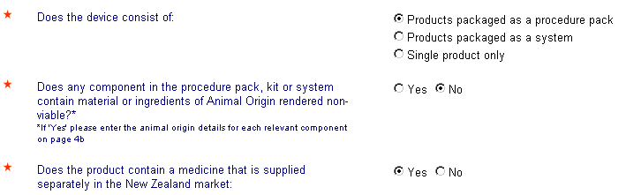  Page 4a will be added to the form to collect information about the medicine supplied separately in New Zealand.  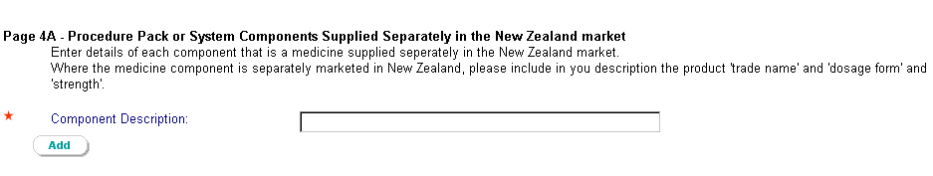  The information sought is to include:  The product name, dosage form and strength.  To complete the form, follow the instructions below.

Enter the Component Description | Complete the ‘Component Description’ where the information includes the  - Product name  - Dosage form and  - strength  Select the button to pass the details to the Component List.  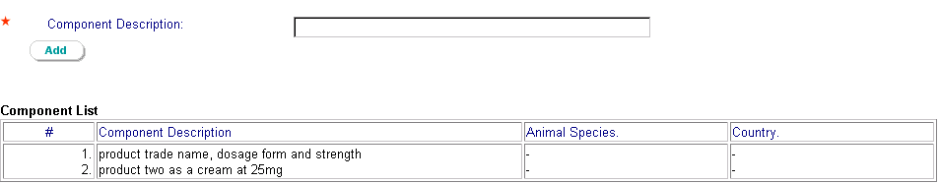  Note:  - The ‘Component Description’ should include the information required to identify the medicine product in the New Zealand market. The field has a maximum of 150 characters.  - You may enter any number of components.  - Where a Procedure Pack and 'animal origin' questions have been marked 'Yes', 'Animal Species' and 'Country of Origin' fields will be displayed here for entry.  - Where applicable, details of those additional fields will also be displayed in this list.

Component Declaration | You are required to declare the following:  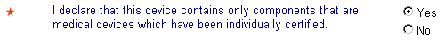

Page 4b - Procedure Pack or System Components Ancillary
Procedure Pack or System Components Ancillary | Page 4b will be displayed if, on Page 1 the following had a 'Yes' response:  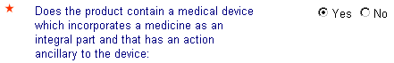  The field displayed is:  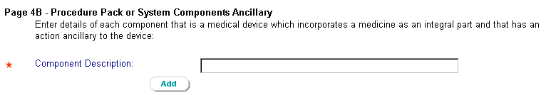  Note:  1. Component Description, is a free text field with a maximum of 150 characters.

Enter Component Description | Enter the 'Component Description' then select the button. Details will be displayed in the Component List:  Note:  - Where a Procedure Pack and 'animal origin' questions have been marked 'Yes', 'Animal Species' and 'Country of Origin' fields will be displayed here for entry.  - Where applicable, details of those additional fields will also be displayed in this list.

Component Declaration | You are required to declare the following:  Note: Declarations for either pages (4a and 4b) are independent. If both Page 4a and Page 4b require completion then the declaration is required on both.

Page 6 - Declaration
Declaration | Before the Device application can be validated and submitted, you must agree to the compulsory part of the declaration on Page 6 of the notification form. Read the information carefully and complete the “I agree” response in the declaration. Please Note there is a second part to the declaration that is optional and should be completed where possible.  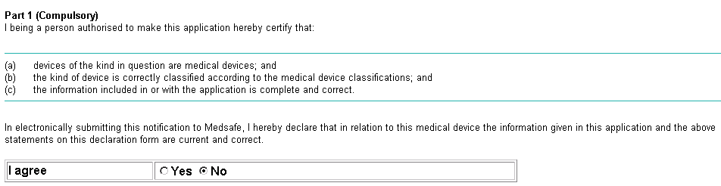  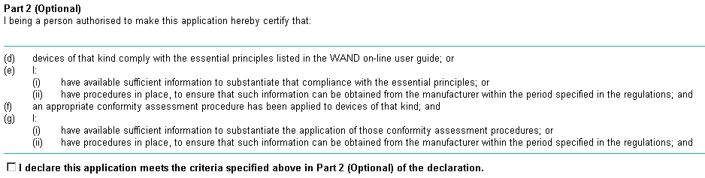

Record Time Taken | The form provides the facility to record the time it takes you to complete a notification.

Completing the Form | The form may be saved at any stage of your data entry. Similarly, 'Close' will save the form and return you to the WAND Home page.
 |  |  | This will display details of all the fields completed for the Medical Device Notification form. Other functions that you can perform are:
This will perform a validation of the form against certain business rules such as ensuring all mandatory fields have been entered. The validation messages will appear at the top of each page such as (for example):
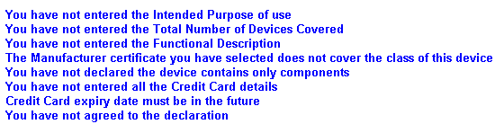

These messages are 'hyperlinked' and selecting one will take you to the page containing the error to complete the entry.

When all errors have been fixed you will see the following validation message:

This will perform a validation and then submit the form to Medsafe.

If the validation is successful the form will be submitted with the following message:

(login id), your Device Application 020731-TGAC-5CKDTQ has been submitted for processing.
Thank you

Note:
            - Medsafe does not have access to Client's draft copies of their Notifications.
            - Submitting a form sends the form to a database within Medsafe for code table maintenance if necessary and subsequent reporting.

View Submitted Device Notification | After a Device Notification has been submitted, you will be able to manage your list of lodged Device Notifications. Notifications will remain in this list until it is passed to New Zealand for reporting.  To view lodged applications select:  View Lodged Medical Device Application on the WAND Home page.  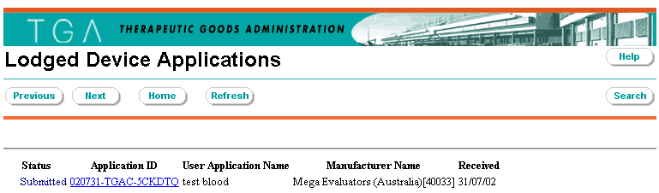

Clone an Approved Australian Medical Device Notification

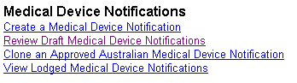

Clone an approved Australian medical device | This facility has been created to facilitate the easy notification of a medical device into the Medsafe database where the medical device has already been ‘included’ in the Australian market. Information that has been ‘included’ in Australia can be copied to make a Medsafe notification but  - is submitted against the New Zealand declaration, and  - is ‘owned’ by the New Zealand Sponsor

Introduction | From the WAND Home page, select  A new form will open for data entry. The form will honour the following rules for selection  The DEAL application must be for an  - Included medical device that has been entered on the ARTG  - And is “owned” by a nominated Australian Sponsor  Enter the Australian Sponsor Client Id number  and then the DEAL application Id number.  If either value is incorrect or the relationship between the entries is incorrect,  the “copy” function will not operate and you will be presented with the following message:

Copy a DEAL application | 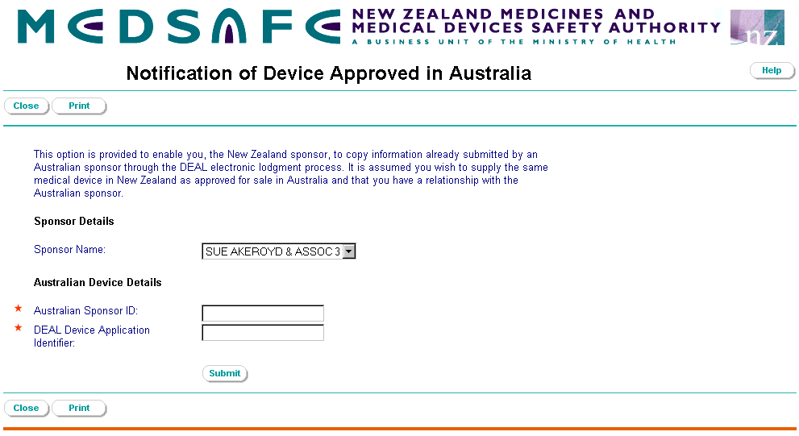

Make a copy | From the WAND Home page, select
 |  | 1. | Your Sponsor name will be populated into the notification form.
 |  | 2. | Enter the Client Id number for the Australian Sponsor of the medical device you wish to copy.
 |  | 3. | Enter the complete (syntax correct) DEAL application Id for the medical device you wish to copy.
 |  | 4. | Hit the button. A successful copy will result in the copied application being displayed ready for submission.  - If this is not the correct Australian medical device, the “Close’ button cancels the copy.  - If correct, the declaration should be completed and the notification can be submitted with the ‘Submit’ button.  Please note the form indicates  - that you are the New Zealand sponsor (applicant) for this Medsafe notification, regardless of the Australian Sponsor, and  - quotes the source of the copy – the DEAL application number.
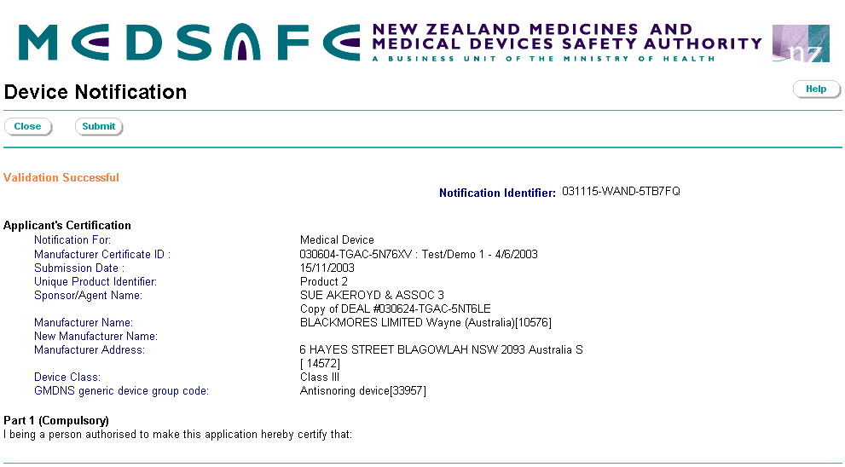
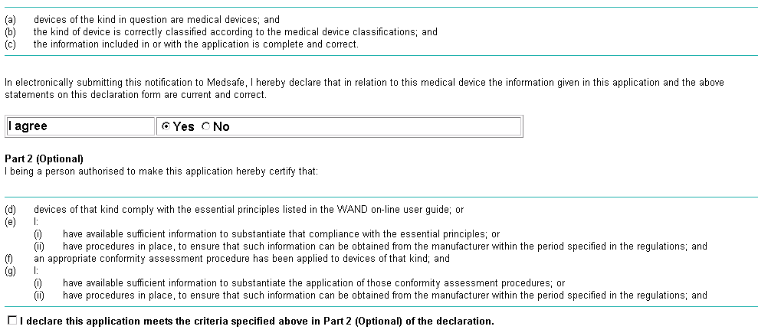

Appendix 1 – Form: Notification of a Manufacturer's Conformity Evidence

Page 1 – Notification Details
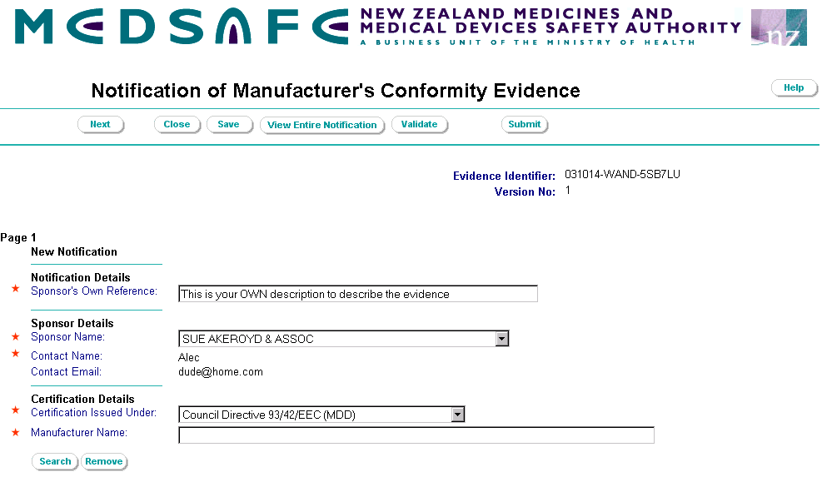
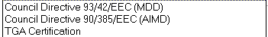

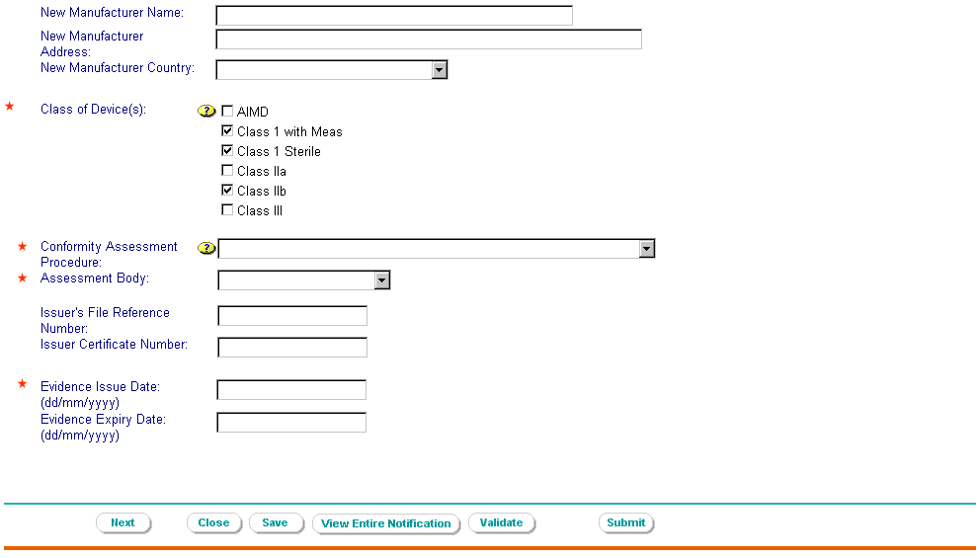
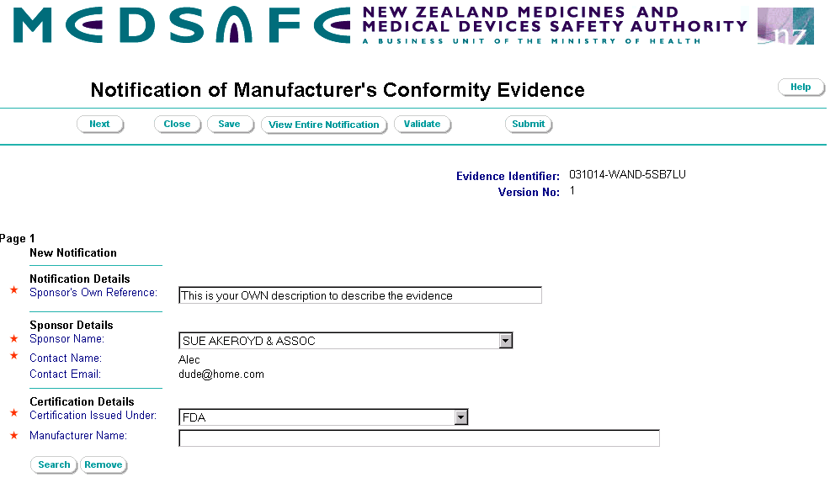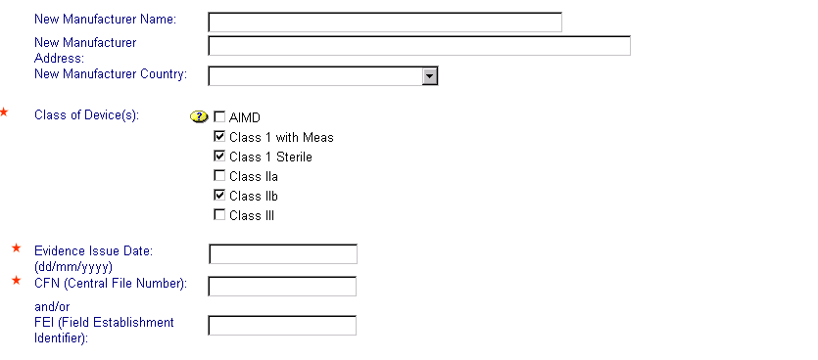
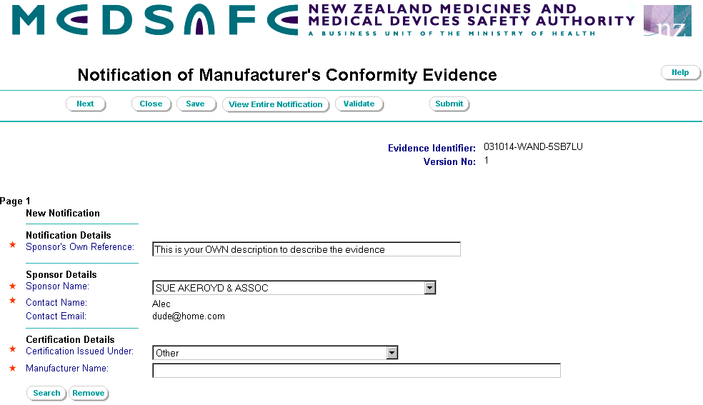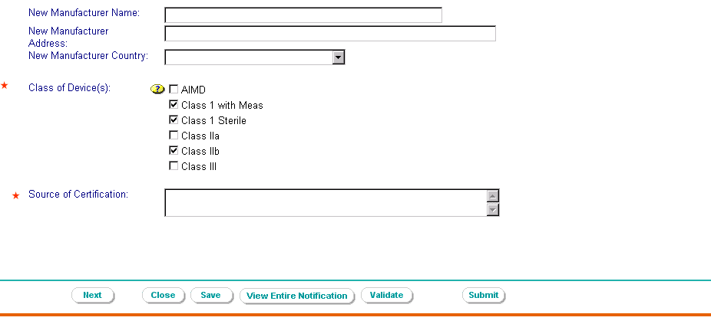
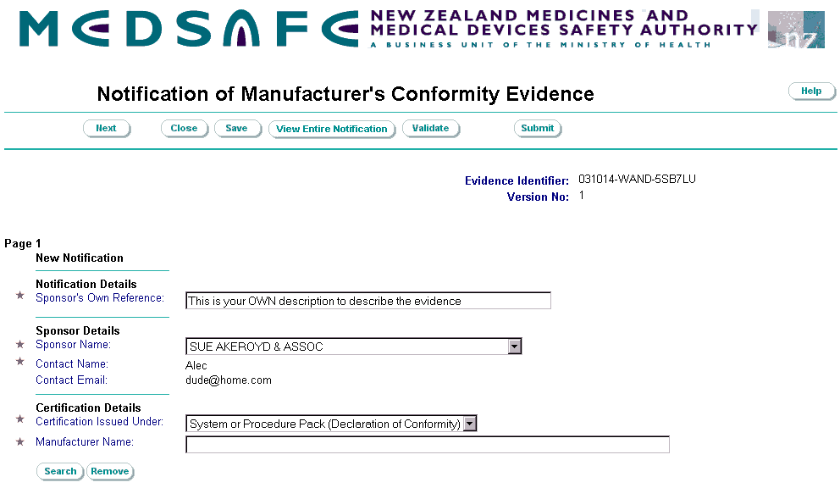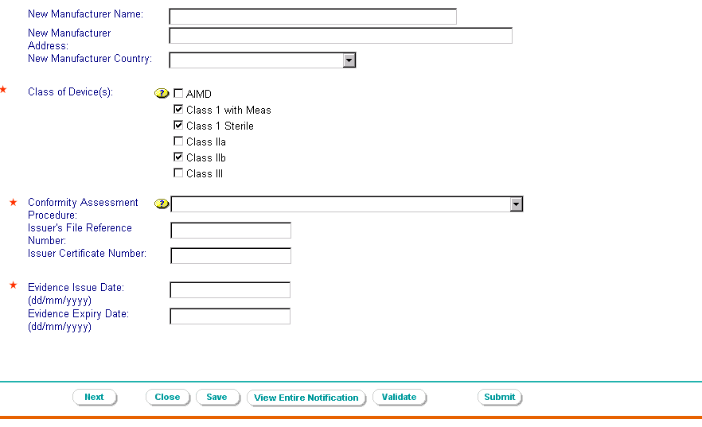

Page 2 – Scope of the Certification
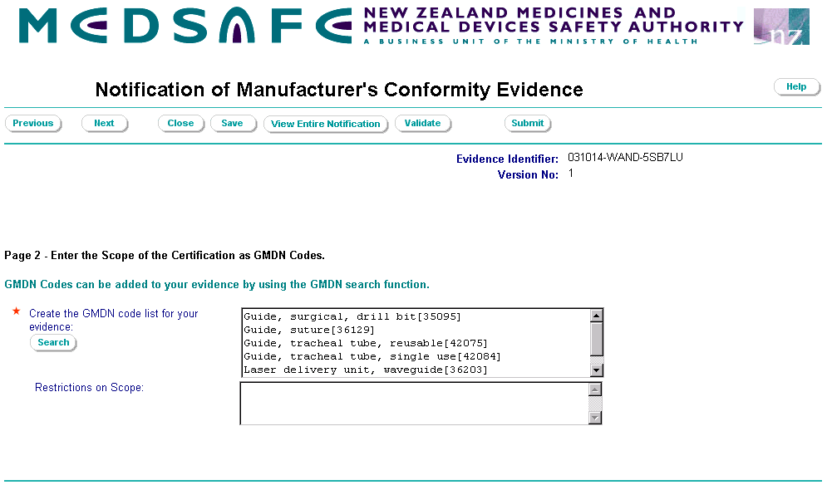

Page 3 – Supporting Documentation
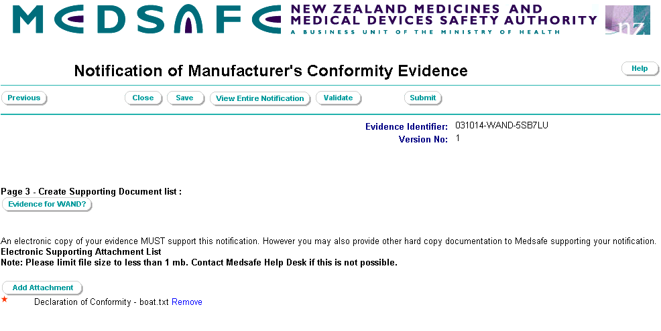
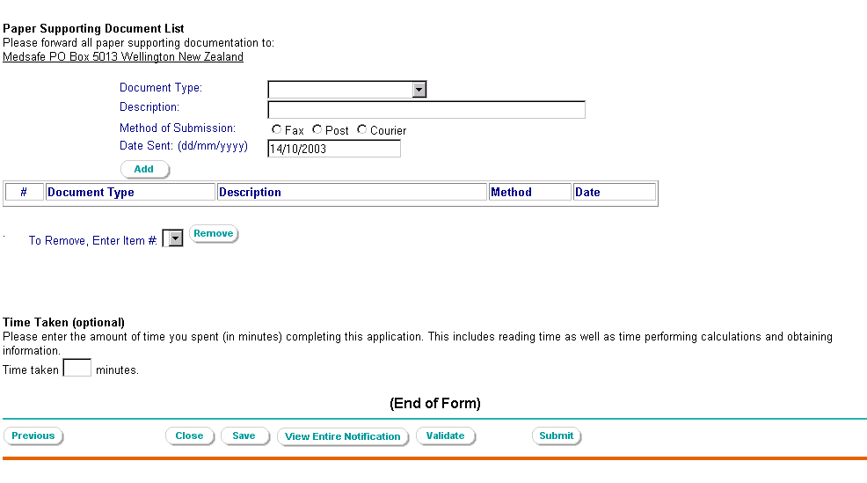

Appendix 2 – Form: Medical Device Notification
Appendix 2 provides the screen shots of all the pages available for a Medical Device Notification. As identified in the User Guide, not all pages are used for each notification. The notification will build depending on the answers to questions on Page 1 which provide details about the device. For further details, refer to the flow diagram on page 33 of the User Guide.

Page 1 – Notification (Specific) Details

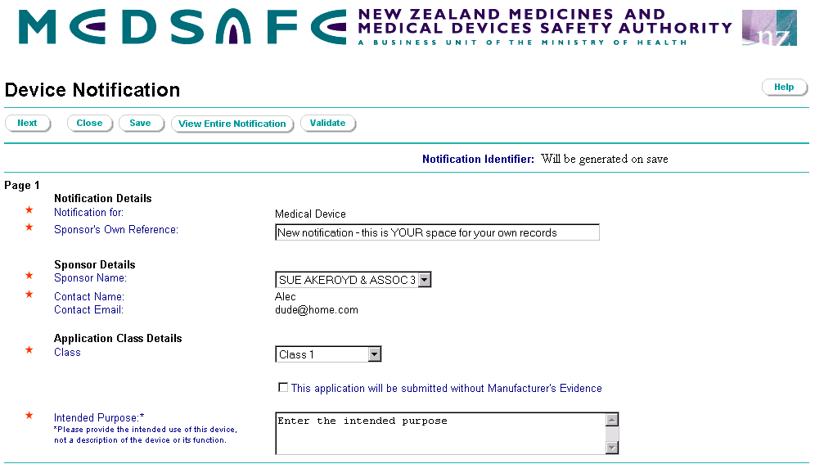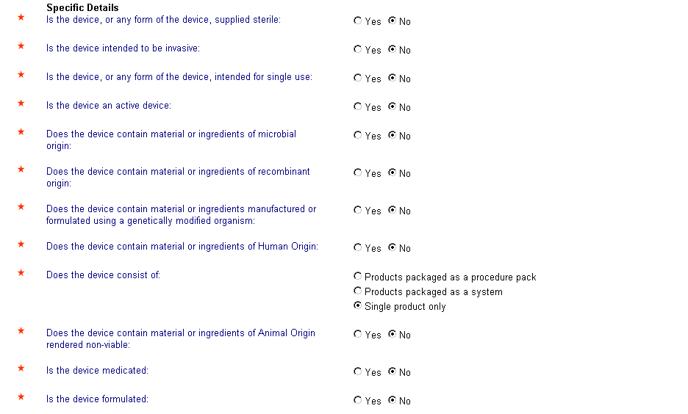
Page 2A – Manufacturing Details (for Class 1 or with No evidence Notifications)
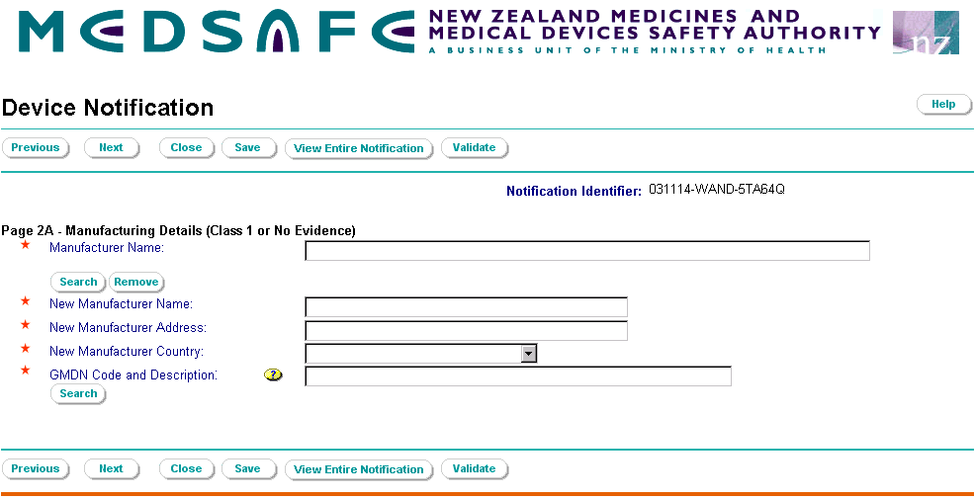

If the checkbox for a system is selected in the device details on page 1,
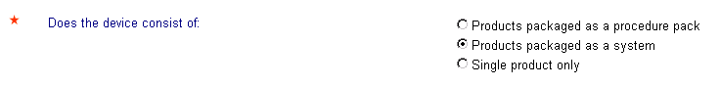
The form will include a data field for entry of the System name

If the No Evidence option is used and the medical device is a high risk device Class III or AIMD, this page will also present two additional fields for data entry

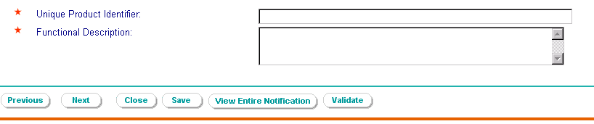
Page 2B – Manufacturing Details (Not Class I or no evidence)

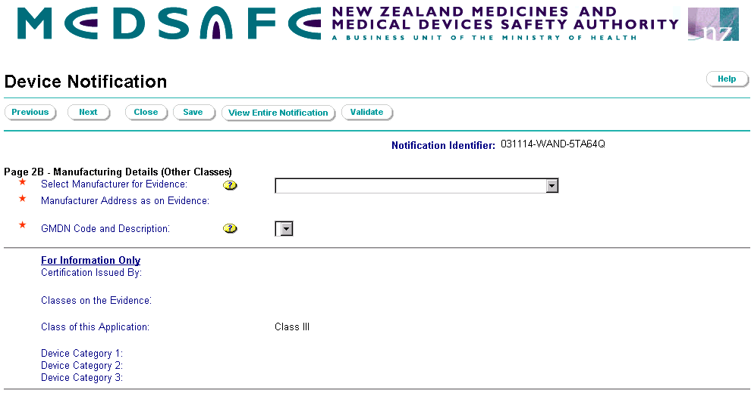
Select the name of your manufacturer from your own list of completed conformity evidence
Select the relevant evidence from your own list of completed conformity evidence

If the checkbox for a system is selected in the device details on page 1,
The form will include a data field for entry of the System name

If the notification is for a Class III or AIMD, additional information fields are presented for data entry
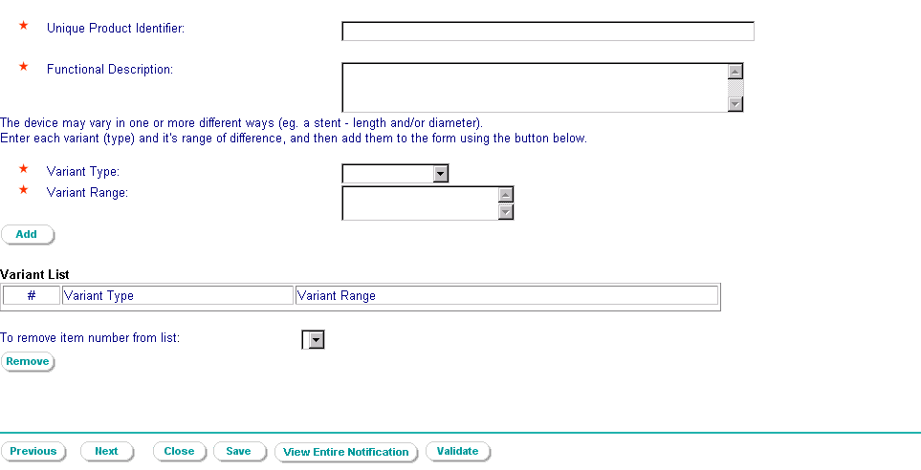

When you enter the following combination in the specific details section of Page 1:
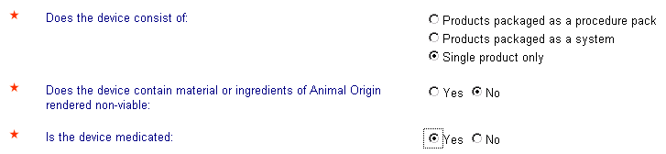

Form Page 3A – Medicated or Formulated Details is presented

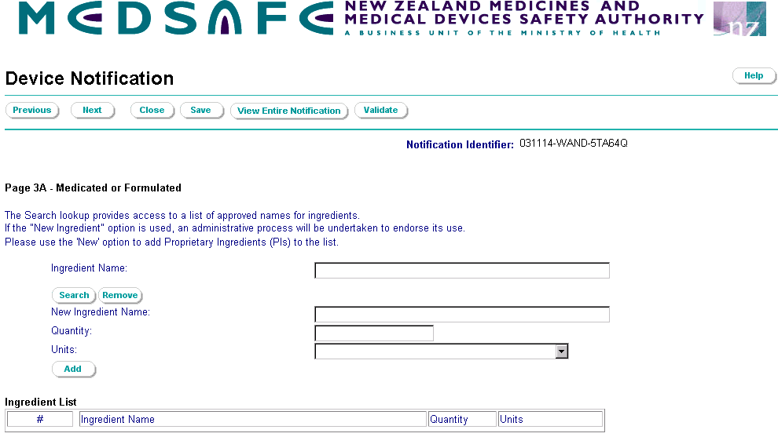
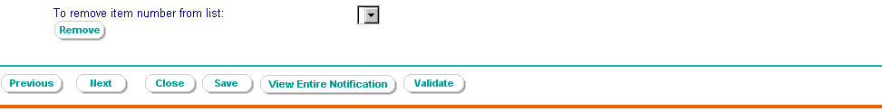

When you enter the following combination in the specific details section of Page 1:
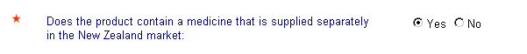

Form Page 4A – Procedure Pack or System Components supplied separately in the New Zealand market is presented

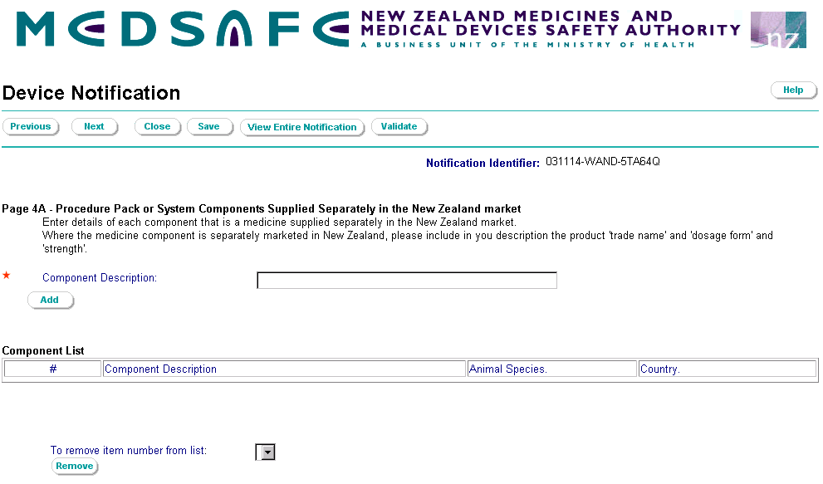

When you enter the following combination in the specific details section of Page 1:
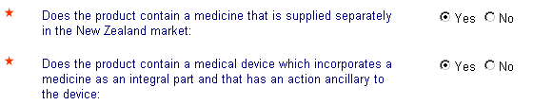

Form Page 4 B – Procedure Pack or System Components (Ancillary) is presented

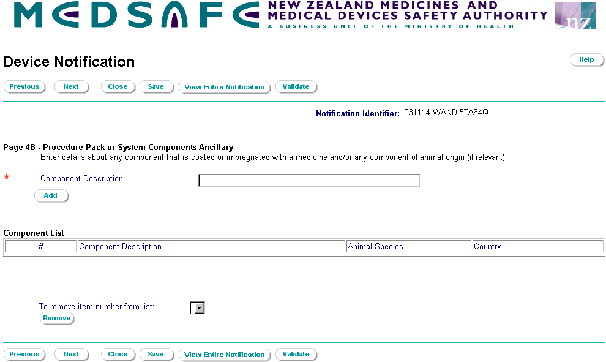

Page 6 – The notification summary and declaration
